Flask-2

Assignment Questions

Assignment

Q1. Explain GET and POST methods.

A-1)While the HTTP POST method is used to send data to a server to create or update a resource, the HTTP GET method is used to request data from a specified resource and should have no other effect. HTTP POST request provides additional data from the client to the server message body.

Q2. Why is request used in Flask?

The Request, in Flask, is an object that contains all the data sent from the Client to Server.

This data can be recovered using the GET/POST Methods.

Q3. Why is redirect() used in Flask?

A-3)Flask class has a redirect() function. When called, it returns a response object and redirects the user to another target location with specified status code. location parameter is the URL where response should be redirected.

Q4. What are templates in Flask? Why is the render_template() function used?

a-4)render_template is used to generate output from a template file based on the Jinja2 engine that is found in the application's templates folder. Note that render_template is typically imported directly from the flask package instead of from flask.

Q5. Create a simple API. Use Postman to test it. Attach the screenshot of the output in the Jupyter Notebook.

Note:  Create your assignment in Jupyter notebook and upload it to GitHub & share that GitHub repository link through your dashboard. Make sure the repository is public.

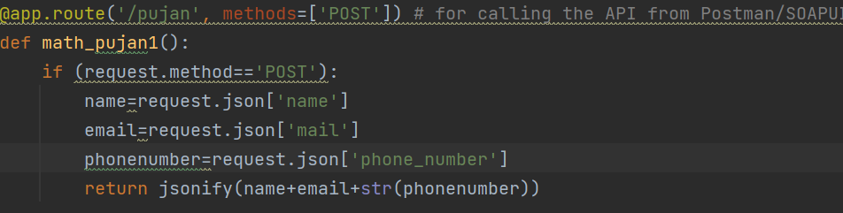

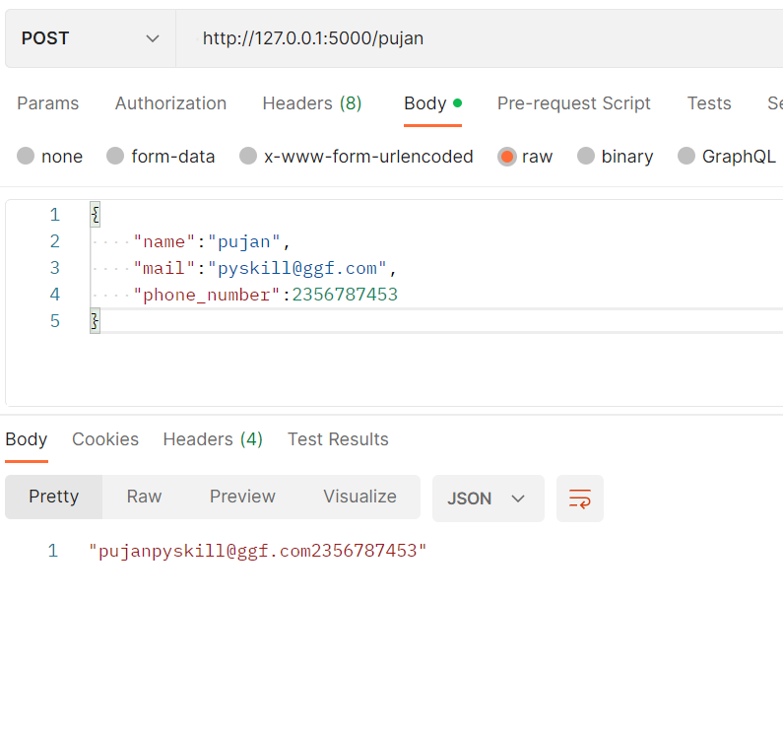

Data Science Masters